Brief on Coleg Gwent Health and Social Care Students
Prior to the COVID-19 Pandemic, the Aneurin Bevan University Health Board had worked collaboratively with Coleg Gwent to offer health and social care students an opportunity to undertake a placement within our hospitals. These students are the future health and social care workforce.
The pandemic meant we had to postpone these placements and this has significantly impacted on health and social care student’s ability to gain valuable practical care experience. As a way of supporting our patients who may be isolated due to restricted visiting, students from the School of Care at Coleg Gwent have been recruited as Ffrind i mi volunteers to support patients on some of our hospital wards.
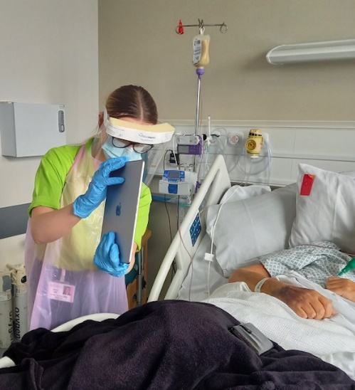
As volunteers, students are able to achieve competencies in their studies such as communication, empathy and listening skills. All the students have gone through a full volunteer recruitment process and have been trained in infection control, confidentiality, dignity and respect. All students are aware of and wear appropriate PPE and are not supporting patients in high risk areas. In addition to this they have been trained in how to empower patients in using digital technology to connect with their family and friends.
Although this is a new initiative we have already seen the significant benefits that students can provide in supporting patients to connect with their families. Volunteering is providing the students with a valuable learning experience, including communication skills, the eths of person centred care and digital inclusion.

Quote from Allison Werner Employer Engagement Advisor- Care & Community Studies
"It has been great working with the Person-Centred Care team in ABUHB to pull together this student volunteer programme in such challenging times. This has given our students an opportunity to enhance their learning and an insight into potential future careers with ABUHB."

Harriett Saunders, Health and Social Care Student, Coleg Gwent

From enquiring about volunteering to being in the hospital the entire process has been well organised and well planned out. Since starting volunteering, the person centred care team have been absolutely amazing and welcoming. They make sure that I am comfortable with how much I interact with patients and ensure that I am not left alone with a patient until I am confident in doing so. The experience has already allowed me to gain valuable insight into firstly, a hospital setting but also how patients are struggling with current circumstances and hopefully how volunteers like myself can impact a patients day. It’s a wonderful experience and i’m enjoying every minute of it

Elena Hall, Health and Social Care Student, Coleg Gwent
At 17 it’s really hard to find an opportunity where I can give back to the community but when I saw the Volunteering position with the Person centred care team I knew it interested me. The process what organised and quick and I found all of the instructions very clear for the forms. The training sessions were well executed especially due to being remote and as soon as I met the team I felt comfortable. This position is really awarding and being part of it has been really eye opening! I’ve felt comfortable throughout the whole process and look forward to every shift knowing it’s making a difference!
